 | 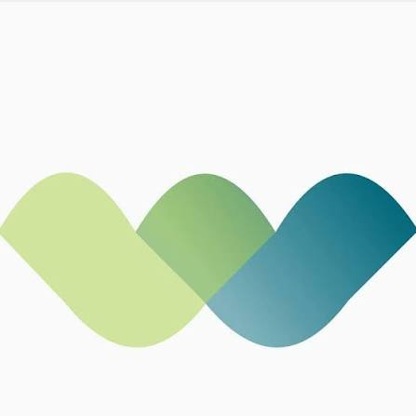 | Workforce Group  Unclaimed profile | Jobs & Recruitment | Nigeria

Jobs & Recruitment  Industry | Nigeria  Country | Lagos, Nigeria  Head office | 2004  Founded

Key information
Industry | Jobs & Recruitment
Country | Nigeria
Founded | 2004
Head office | Lagos, Nigeria
Employees | 9000+

About
Workforce Group is one of Nigeria’s leading HR and business consulting firms, founded in 2004 and headquartered in Lagos. It has built a reputation across recruitment, outsourcing, learning and development, assessment, and broader people-management advisory services for organizations operating in Nigeria and beyond.
The company positions itself as a talent and business solutions firm rather than a narrow recruitment agency. Its work spans talent sourcing, executive search, leadership assessment, staffing, learning, market-entry support, and business advisory, with clients across sectors such as technology, telecoms, oil and gas, financial services, FMCG, and the third sector. That breadth makes Workforce Group more structurally complete than a typical staffing firm, since it supports how organizations acquire, develop, deploy, and manage people.
A key part of its value proposition is scale. Workforce Group says it draws on more than 125 highly experienced consultants and over 9,000 associate staff across the continent, while external company profiles place its employee count in the low thousands. That scale supports both enterprise clients and large workforce programs, especially in markets where organizations need flexible, high-volume people operations.
The company also emphasizes learning and leadership development as a core offering, not just a side service. Its learning practice is built around helping organizations identify leadership gaps, develop capability, and improve performance through targeted training and assessment. In practice, that means Workforce Group sits at the intersection of HR services, organizational consulting, and workforce enablement.
At Workforce, we believe that meaningful impact begins with people. Mission statement

Trust and reputation measures
Trust Score  Not yet rated  Needs reviews and evidence | Profile Strength  36/100  Incomplete Profile | Evidence  No evidence recorded yet | Status  Unclaimed profile

Brands Trust Score A reputation measure built from approved reviews and evidence under a published methodology. It is not a measure of how complete a profile is, and payment never changes it.
Profile Strength How complete and well maintained the profile is. It does not change the Trust Score.
Evidence coverage How much of this profile is backed by recorded sources, and how independent they are.
Status No company representative has claimed this profile yet. It is compiled from public sources by Brands.Ng.

Brand identity
Primary logo

Latest news about Workforce Group
31 Aug 2026 From Merchant Bank to Tier‑One Contender: How Nneka Onyeali‑Ikpe Is Rebuilding Fidelity Bank
19 Aug 2026 From Econet to Chapel Hill Denham: How Bolaji Balogun Built a Nigerian Deal-Making Powerhouse
10 Aug 2026 Sim Shagaya: How the Konga Founder Built Nigeria’s E-commerce Pioneer and Reinvented Himself in Education
28 May 2026 MyJobMag Review 2026: Is It Legit for Job Seekers in Nigeria?
28 May 2026 Workforce Group Review 2026: Is It Legit for Jobs in Nigeria?
Articles published on Brands.Ng that mention this company.

Media, contacts and social
Head office | Lagos, Nigeria

About this document
Generated on 25 October 2026 from the Brands.Ng Brand Passport.
It contains only published, sourced information and may have changed since. Check the linked sources before relying on a fact.
"Verified" means Brands.Ng has verified the company through its own review process. It is not a government certification and does not guarantee every statement.
Live profile: https://brands.ng/companies/workforce-group/
How to read the source labels
Company-confirmed | Supplied by an authorised company representative and approved by Brands.Ng.
Publicly documented | Backed by a regulator or other primary record.
Reported by independent source | Reported by a publication that is not the company.
Brands.Ng research | Compiled by Brands.Ng editors; never counted as independent corroboration.
Not publicly verified | No source yet. It is left blank rather than guessed.

