 | 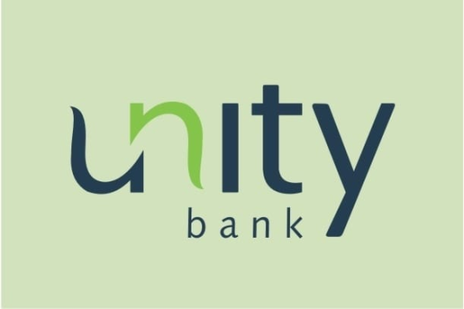 | Unity Bank Plc  Unclaimed profile | Banking, Finance, Investments | Nigeria

Banking, Finance, Investments  Industry | Nigeria  Country | Victoria Island, Lagos  Head office | 2006  Founded

Key information
Industry | Banking, Finance, Investments
Country | Nigeria
Founded | 2006
Head office | Victoria Island, Lagos
Website | unitybankng.com
Employees | 2500+

About
Unity Bank Plc is a Nigerian commercial bank that commenced operations in January 2006 following the consolidation of nine financial institutions during the banking-sector reforms led by the Central Bank of Nigeria. The institutions that formed the bank included Intercity Bank, First Interstate Bank, Tropical Commercial Bank, Pacific Bank, Centre Point Bank, Societe Bancaire, NNB International Bank, Bank of the North, and New Africa Bank. The consolidation was part of efforts to strengthen Nigeria’s banking industry, improve financial stability, and ensure that banks met the higher capital requirements introduced under the reform programme.
The bank’s origins can be traced to Intercity Bank Limited, which was incorporated in 1987 and licensed to conduct commercial banking business that same year. Following the consolidation process, the institution adopted the name Unity Bank Plc and brought together the corporate, retail, investment, and regional banking capabilities of its predecessor institutions. This history gave Unity Bank an extensive branch network and a broad customer base across different parts of Nigeria.
Headquartered at Plot 42, Ahmed Onibudo Street, Victoria Island, Lagos, Unity Bank has operated as a commercial bank with national authorisation. Its services have traditionally included retail and corporate banking, business banking, electronic banking, payments, deposits, and credit facilities for individuals, small businesses, corporations, and public-sector customers.
Agriculture has remained one of Unity Bank’s most notable areas of strategic interest. Through financing and banking solutions for farmers, cooperatives, processors, distributors, and other agribusinesses, the bank has sought to support agricultural production and value-chain development in Nigeria. This emphasis reflects the importance of agriculture to employment, food security, rural livelihoods, and economic activity across the country.
To be Nigeria's most customer-focused bank, delivering value through innovative products and agricultural sector expertise. Mission statement

Trust and reputation measures
Trust Score  Not yet rated  Needs reviews and evidence | Profile Strength  39/100  Incomplete Profile | Evidence  No evidence recorded yet | Status  Unclaimed profile

Brands Trust Score A reputation measure built from approved reviews and evidence under a published methodology. It is not a measure of how complete a profile is, and payment never changes it.
Profile Strength How complete and well maintained the profile is. It does not change the Trust Score.
Evidence coverage How much of this profile is backed by recorded sources, and how independent they are.
Status No company representative has claimed this profile yet. It is compiled from public sources by Brands.Ng.

Brand identity
Primary logo

Products and services
• Retail banking
• corporate banking
• electronic banking
• SME finance
• and agricultural financing
Listed in the company profile.

Latest news about Unity Bank Plc
13 Aug 2026 Allen Onyema and the Air Peace Story: Building Nigeria’s Airline Powerhouse Amid Ambition and Controversy
Articles published on Brands.Ng that mention this company.

Media, contacts and social
Head office | Victoria Island, Lagos
Website | https://www.unitybankng.com

About this document
Generated on 14 October 2026 from the Brands.Ng Brand Passport.
It contains only published, sourced information and may have changed since. Check the linked sources before relying on a fact.
"Verified" means Brands.Ng has verified the company through its own review process. It is not a government certification and does not guarantee every statement.
Live profile: https://brands.ng/companies/unity-bank/
How to read the source labels
Company-confirmed | Supplied by an authorised company representative and approved by Brands.Ng.
Publicly documented | Backed by a regulator or other primary record.
Reported by independent source | Reported by a publication that is not the company.
Brands.Ng research | Compiled by Brands.Ng editors; never counted as independent corroboration.
Not publicly verified | No source yet. It is left blank rather than guessed.

