 | 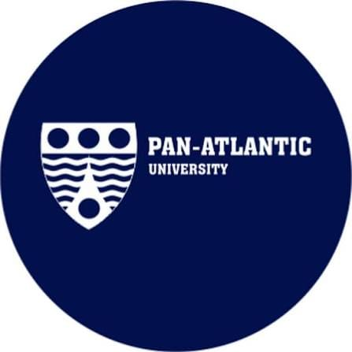 | Pan-Atlantic University  Unclaimed profile | Education | Nigeria

Education  Industry | Nigeria  Country | Lekki Lagos  Head office | 2002  Founded

Key information
Industry | Education
Country | Nigeria
Founded | 2002
Head office | Lekki Lagos
Employees | 1000+

About
Pan-Atlantic University is one of Nigeria’s most distinctive private universities, founded in 2002 with a clear mission to combine academic excellence with ethical leadership, human development, and practical impact. It stands out in the Nigerian higher education landscape not simply as another private university, but as the parent institution of Lagos Business School, which has become its most visible and influential academic brand.
At the center of the university’s reputation is Lagos Business School, widely regarded as the leading business school in West Africa and one of the continent’s top-ranked institutions. Its strength lies in the way it blends rigorous management education with a strong moral and humanistic framework. That approach has made it especially attractive to senior executives, entrepreneurs, and public-sector leaders who want not only technical knowledge but also a broader understanding of leadership, governance, and responsibility.
LBS is particularly known for its executive education portfolio. Programs such as the Executive MBA, Senior Management Programme, and owner-manager courses draw experienced professionals from across Nigeria and the wider West African region. These offerings are designed for people already in leadership roles, which gives the school a highly practical orientation and a strong connection to real-world business challenges. The result is an institution that functions as both a training ground for leaders and a forum for ideas shaping modern African business practice.
Another major part of Pan-Atlantic University’s influence is its alumni network. Graduates of Lagos Business School occupy senior positions in major companies, government institutions, and entrepreneurial ventures across Nigeria and beyond. That network has helped reinforce the school’s brand and expand its influence far beyond the classroom. In many professional circles, an LBS education is seen as a signal of seriousness, discipline, and executive readiness.
To develop business leaders who will transform Africa and drive economic growth. Mission statement

Trust and reputation measures
Trust Score  Not yet rated  Needs reviews and evidence | Profile Strength  36/100  Incomplete Profile | Evidence  No evidence recorded yet | Status  Unclaimed profile

Brands Trust Score A reputation measure built from approved reviews and evidence under a published methodology. It is not a measure of how complete a profile is, and payment never changes it.
Profile Strength How complete and well maintained the profile is. It does not change the Trust Score.
Evidence coverage How much of this profile is backed by recorded sources, and how independent they are.
Status No company representative has claimed this profile yet. It is compiled from public sources by Brands.Ng.

Brand identity
Primary logo

Media, contacts and social
Head office | Lekki Lagos

About this document
Generated on 23 October 2026 from the Brands.Ng Brand Passport.
It contains only published, sourced information and may have changed since. Check the linked sources before relying on a fact.
"Verified" means Brands.Ng has verified the company through its own review process. It is not a government certification and does not guarantee every statement.
Live profile: https://brands.ng/companies/pan-atlantic-university/
How to read the source labels
Company-confirmed | Supplied by an authorised company representative and approved by Brands.Ng.
Publicly documented | Backed by a regulator or other primary record.
Reported by independent source | Reported by a publication that is not the company.
Brands.Ng research | Compiled by Brands.Ng editors; never counted as independent corroboration.
Not publicly verified | No source yet. It is left blank rather than guessed.

