 | 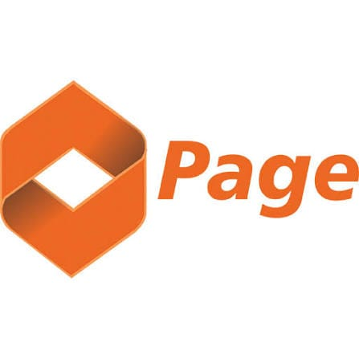 | Page Financials  Unclaimed profile | Banking, Finance, Investments | Nigeria

Banking, Finance, Investments  Industry | Nigeria  Country | Ikeja, Lagos  Head office | 2014  Founded

Key information
Industry | Banking, Finance, Investments
Country | Nigeria
Founded | 2014
Head office | Ikeja, Lagos
Website | pagefinancials.com
Employees | 150+

About
Page Financials is a Nigerian retail-finance institution that provides personal loans, business finance, savings, investments, payments, and other financial services. It operates under a licence issued by the Central Bank of Nigeria and uses both digital channels and physical offices to serve individuals, salary earners, entrepreneurs, and corporate customers.
The company commenced business in 2014, although some profiles refer to 2015 as its founding year. It was established to provide more accessible retail financial services to customers who may require quick credit, flexible investment products, or convenient digital banking tools. The business operates under the registered name Page International Finance Company Limited and trades publicly as Page Financials.
Page Financials’ lending business is centred on personal and small-business finance. Personal loans are available to eligible salaried employees, self-employed individuals, and other qualifying customers for purposes such as household expenses, emergencies, education, rent, medical needs, and other personal obligations. The company’s online and digitally supported application process is designed to shorten approval and disbursement timelines compared with traditional bank lending.
The company also provides loans to micro, small, and medium-sized businesses. These facilities may be used for working capital, inventory purchases, business expansion, asset acquisition, and other operational requirements. Page Financials advertises SME financing of up to ₦50 million, although the amount, pricing, repayment period, and eligibility requirements depend on the customer’s profile and the specific product.
To provide fast, transparent, and accessible financial services to Nigerian individuals and small businesses. Mission statement

Trust and reputation measures
Trust Score  Not yet rated  Needs reviews and evidence | Profile Strength  39/100  Incomplete Profile | Evidence  No evidence recorded yet | Status  Unclaimed profile

Brands Trust Score A reputation measure built from approved reviews and evidence under a published methodology. It is not a measure of how complete a profile is, and payment never changes it.
Profile Strength How complete and well maintained the profile is. It does not change the Trust Score.
Evidence coverage How much of this profile is backed by recorded sources, and how independent they are.
Status No company representative has claimed this profile yet. It is compiled from public sources by Brands.Ng.

Brand identity
Primary logo

Products and services
• Personal loans
• SME loans
• savings
• fixed deposits
• investments
• mobile banking
• internet banking
• ATM cards
• transfers
• bill payments
• and POS solutions
Listed in the company profile.

Media, contacts and social
Head office | Ikeja, Lagos
Website | https://www.pagefinancials.com

About this document
Generated on 14 October 2026 from the Brands.Ng Brand Passport.
It contains only published, sourced information and may have changed since. Check the linked sources before relying on a fact.
"Verified" means Brands.Ng has verified the company through its own review process. It is not a government certification and does not guarantee every statement.
Live profile: https://brands.ng/companies/page-financials/
How to read the source labels
Company-confirmed | Supplied by an authorised company representative and approved by Brands.Ng.
Publicly documented | Backed by a regulator or other primary record.
Reported by independent source | Reported by a publication that is not the company.
Brands.Ng research | Compiled by Brands.Ng editors; never counted as independent corroboration.
Not publicly verified | No source yet. It is left blank rather than guessed.

