 | 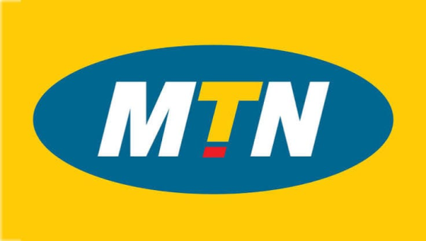 | MTN Nigeria  Everywhere You Go  Unclaimed profile | Telecommunications | Nigeria

Telecommunications  Industry | Nigeria  Country | Lagos, Nigeria  Head office | 2001  Founded

Key information
Industry | Telecommunications
Country | Nigeria
Founded | 2001
Head office | Lagos, Nigeria

About
MTN Nigeria Communications Plc is one of the country’s leading telecommunications and digital services providers, offering voice, data, enterprise connectivity, and mobile financial services to millions of customers nationwide. Headquartered in Lagos, the company is part of the MTN Group, a multinational telecommunications group with operations across Africa and the Middle East.
Launched in Nigeria in 2001, MTN Nigeria has grown into one of Africa’s largest communications providers and remains a major force in the Nigerian mobile market. The company states that it connects approximately 77 million people across the country and has maintained a leadership position in coverage, capacity, and innovation since launch. Its nationwide network supports individual consumers, SMEs, large enterprises, and public sector users with services designed for everyday communication and business productivity.
MTN Nigeria’s core portfolio includes voice calls, internet access, text messaging, broadband fixed wireless access, and a range of value-added and digital services. These offerings extend to mobile money, device and accessory sales, digital services, interconnect, and roaming solutions. The company also continues to expand its network capabilities, including 5G, while maintaining broad coverage across Nigeria.
As a listed company on the Nigerian Exchange, MTN Nigeria combines the scale of a major telecom operator with the governance expectations of a publicly traded business. Its corporate strategy is centred on digital inclusion, improved connectivity, and the development of solutions that support economic growth and customer convenience. The company also emphasises its role in enabling businesses and individuals to communicate, transact, and access digital services more efficiently.
To lead digital solutions for Nigeria's progress Mission statement

Trust and reputation measures
Trust Score  Not yet rated  Needs reviews and evidence | Profile Strength  36/100  Incomplete Profile | Evidence  No evidence recorded yet | Status  Unclaimed profile

Brands Trust Score A reputation measure built from approved reviews and evidence under a published methodology. It is not a measure of how complete a profile is, and payment never changes it.
Profile Strength How complete and well maintained the profile is. It does not change the Trust Score.
Evidence coverage How much of this profile is backed by recorded sources, and how independent they are.
Status No company representative has claimed this profile yet. It is compiled from public sources by Brands.Ng.

Brand identity
Primary logo

Products and services
• Voice calls
• internet access
• text messaging
• broadband fixed wireless access
• mobile money
• device and accessory sales
• digital services
• interconnect
• and roaming solutions.
Listed in the company profile.

Latest news about MTN Nigeria
19 Aug 2026 From Econet to Chapel Hill Denham: How Bolaji Balogun Built a Nigerian Deal-Making Powerhouse
30 Jun 2026 MTN Nigeria Review 2026: Network Coverage, Data Plans, Customer Service & 5G
29 Jun 2026 Airtel Nigeria Review: Is Airtel Better Than MTN in 2026?
28 Jun 2026 GTBank Review 2026: Nigeria’s Most Admired Bank – But Is It Still the Best?
27 Jun 2026 Telecom Salary Guide Nigeria 2026: MTN vs Airtel vs Glo
Articles published on Brands.Ng that mention this company.

Media, contacts and social
Head office | Lagos, Nigeria

About this document
Generated on 23 October 2026 from the Brands.Ng Brand Passport.
It contains only published, sourced information and may have changed since. Check the linked sources before relying on a fact.
"Verified" means Brands.Ng has verified the company through its own review process. It is not a government certification and does not guarantee every statement.
Live profile: https://brands.ng/companies/mtn-nigeria/
How to read the source labels
Company-confirmed | Supplied by an authorised company representative and approved by Brands.Ng.
Publicly documented | Backed by a regulator or other primary record.
Reported by independent source | Reported by a publication that is not the company.
Brands.Ng research | Compiled by Brands.Ng editors; never counted as independent corroboration.
Not publicly verified | No source yet. It is left blank rather than guessed.

