 | 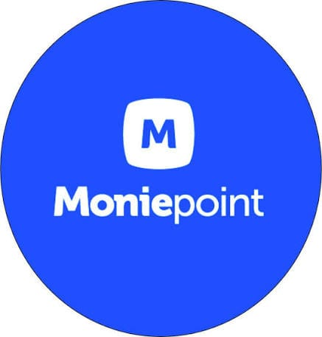 | Moniepoint Business  Unclaimed profile | Fintech | Nigeria

Fintech  Industry | Nigeria  Country | Lagos  Head office | 2015  Founded

Key information
Industry | Fintech
Country | Nigeria
Founded | 2015
Head office | Lagos
Employees | 5000+

About
Moniepoint’s business banking division is best understood as the company’s core operating engine, built after TeamApt shifted in 2019 from B2B banking infrastructure toward direct services for Nigerian small businesses. That pivot mattered because it moved Moniepoint closer to the real financial workflows of SMEs, where payments, cash flow, and short-term credit are tightly connected.
The company’s appeal lies in the way it bundles the tools small businesses actually use every day: POS terminals, current accounts, expense cards, and working capital loans. Instead of offering banking as a distant back-office service, Moniepoint places those functions inside the daily operations of merchants, giving them one system for accepting payments and managing business money.
What makes the lending side especially important is the quality of the data behind it. Moniepoint underwrites credit using transactional evidence generated through its own payment infrastructure, rather than relying only on financial statements or manually reported records. In a market where many SMEs have thin documentation and irregular formal accounting, that gives the company a much stronger view of real business performance.
That data advantage is a meaningful competitive moat. The more businesses process transactions through Moniepoint, the more accurately it can assess cash flow, repayment behavior, and business activity, which in turn improves lending decisions. Over time, that creates a feedback loop that is difficult for competitors to replicate without similar distribution and transaction depth.
Overall, Moniepoint’s business banking segment is not just a product line; it is the main expression of a strategy built around serving Nigerian SMEs at scale with payments, accounts, and credit linked by operational data. That combination has made it one of the more structurally interesting fintech businesses in Nigeria’s digital economy.
To power the dreams of SMEs and make their financial lives easier across Africa. Mission statement

Trust and reputation measures
Trust Score  Not yet rated  Needs reviews and evidence | Profile Strength  34/100  Incomplete Profile | Evidence  No evidence recorded yet | Status  Unclaimed profile

Brands Trust Score A reputation measure built from approved reviews and evidence under a published methodology. It is not a measure of how complete a profile is, and payment never changes it.
Profile Strength How complete and well maintained the profile is. It does not change the Trust Score.
Evidence coverage How much of this profile is backed by recorded sources, and how independent they are.
Status No company representative has claimed this profile yet. It is compiled from public sources by Brands.Ng.

Brand identity
Primary logo

Latest news about Moniepoint Business
3 Sep 2026 Nigeria’s Fintech Giants: Who Is Actually Winning the Race for Customers?
17 Aug 2026 OPay Customer Complaints Investigation: Verified Report on Account Restrictions, Disputes and Regulatory Oversight
28 Jun 2026 GTBank Review 2026: Nigeria’s Most Admired Bank – But Is It Still the Best?
16 Apr 2026 ALAT for Business Review 2026: Is It a Good Business Bank? The Hidden Problems SMEs Should Know
29 Mar 2026 Moniepoint Review 2026: Is It a Good Bank, How Targets Work, and the Hidden Truth Nigerians Should Know
Articles published on Brands.Ng that mention this company.

Media, contacts and social
Head office | Lagos

About this document
Generated on 29 October 2026 from the Brands.Ng Brand Passport.
It contains only published, sourced information and may have changed since. Check the linked sources before relying on a fact.
"Verified" means Brands.Ng has verified the company through its own review process. It is not a government certification and does not guarantee every statement.
Live profile: https://brands.ng/companies/moniepoint-business/
How to read the source labels
Company-confirmed | Supplied by an authorised company representative and approved by Brands.Ng.
Publicly documented | Backed by a regulator or other primary record.
Reported by independent source | Reported by a publication that is not the company.
Brands.Ng research | Compiled by Brands.Ng editors; never counted as independent corroboration.
Not publicly verified | No source yet. It is left blank rather than guessed.

