 | 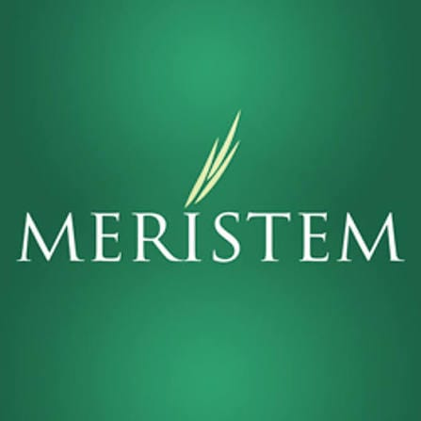 | Meristem Securities  Unclaimed profile | Banking, Finance, Investments | Nigeria

Banking, Finance, Investments  Industry | Nigeria  Country | Ikoyi, Lagos, Nigeria  Head office | 2005  Founded

Key information
Industry | Banking, Finance, Investments
Country | Nigeria
Founded | 2005
Head office | Ikoyi, Lagos, Nigeria
Website | meristemng.com
Employees | 300+

About
Meristem Securities Limited is a Nigerian capital-markets and financial-services group that provides stockbroking, investment banking, wealth management, asset management, trusteeship, registrar services, and related financial solutions. Through its specialised subsidiaries, the group serves retail investors, high-net-worth individuals, corporations, institutional investors, and public-sector organisations in Nigeria and other markets.
The business was originally established as Great Africa Securities in 2003 and adopted the Meristem name in 2005. Some records also trace the wider group’s history to the capital-market services of Great Africa Trust, which had operated since 1994. For accuracy, 2003 is generally used as the group’s founding date, while 2005 marks the rebranding of Great Africa Securities as Meristem Securities.
Meristem’s stockbroking business provides equity and fixed-income trading services to individual and institutional investors. Through its licensed stockbroking subsidiary, the company facilitates transactions in Nigerian securities markets and provides investors with access to investment products, market information, portfolio services, and digital trading channels. The group also offers investor-support and education resources designed to help more Nigerians understand and participate in the capital markets.
Its investment-banking business provides corporate-finance and capital-markets advisory services. These include mergers and acquisitions, business valuation, restructuring, capital raising, financial advisory, securities issuance, and issuing-house functions. These services support companies and institutions seeking to raise funds, complete strategic transactions, improve their financial structures, or access long-term investment capital.
To be the leading investment house in Africa, delivering exceptional value through integrated financial services. Mission statement

Trust and reputation measures
Trust Score  Not yet rated  Needs reviews and evidence | Profile Strength  39/100  Incomplete Profile | Evidence  No evidence recorded yet | Status  Unclaimed profile

Brands Trust Score A reputation measure built from approved reviews and evidence under a published methodology. It is not a measure of how complete a profile is, and payment never changes it.
Profile Strength How complete and well maintained the profile is. It does not change the Trust Score.
Evidence coverage How much of this profile is backed by recorded sources, and how independent they are.
Status No company representative has claimed this profile yet. It is compiled from public sources by Brands.Ng.

Brand identity
Primary logo

Products and services
• Stockbroking
• investment banking
• wealth management
• asset management
• trusteeship
• registrars
• probate services
• lease financing
• and loan financing
Listed in the company profile.

Latest news about Meristem Securities
17 Apr 2026 Is Cowrywise Legit? Before You Invest, Read This Review
Articles published on Brands.Ng that mention this company.

Media, contacts and social
Head office | Ikoyi, Lagos, Nigeria
Website | https://www.meristemng.com

About this document
Generated on 15 October 2026 from the Brands.Ng Brand Passport.
It contains only published, sourced information and may have changed since. Check the linked sources before relying on a fact.
"Verified" means Brands.Ng has verified the company through its own review process. It is not a government certification and does not guarantee every statement.
Live profile: https://brands.ng/companies/meristem-securities/
How to read the source labels
Company-confirmed | Supplied by an authorised company representative and approved by Brands.Ng.
Publicly documented | Backed by a regulator or other primary record.
Reported by independent source | Reported by a publication that is not the company.
Brands.Ng research | Compiled by Brands.Ng editors; never counted as independent corroboration.
Not publicly verified | No source yet. It is left blank rather than guessed.

