 | 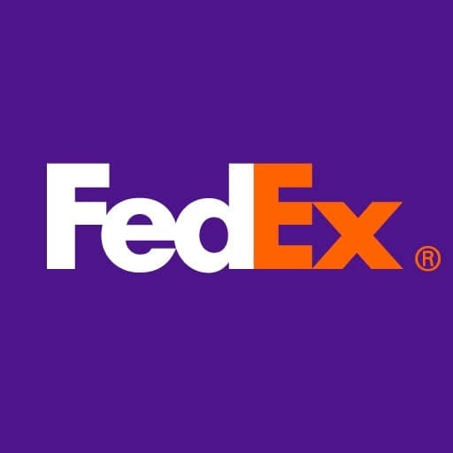 | FedEx Nigeria  Unclaimed profile | Logistics | Nigeria

Logistics  Industry | Nigeria  Country | Lagos, Nigeria  Head office | 1992  Founded

Key information
Industry | Logistics
Country | Nigeria
Founded | 1992
Head office | Lagos, Nigeria

About
FedEx Nigeria is the Nigerian presence of FedEx, the global logistics and express delivery company, offering shipping, courier, and tracking services for both individuals and businesses. It supports domestic delivery within Nigeria as well as international shipping to and from Nigeria, making it a practical option for cross-border commerce, business logistics, and personal parcel movement.
The brand’s Nigerian website places strong emphasis on convenience and shipment visibility. Users can track parcels with a tracking or reference number, access customer support by email, phone, or chat, and use shipping tools designed to simplify international delivery. This digital support layer is important because logistics customers often care as much about monitoring a shipment as they do about the shipment itself.
FedEx Nigeria also reflects the broader structure of a multinational enterprise rather than a standalone local startup. Its Nigeria operation appears to function within the global FedEx system, with pricing, routing, and service standards aligned to the wider corporation. The local site even notes that, effective August 1, 2024, FedEx changed its rating currency in Nigeria from naira to U.S. dollars because of market conditions and currency devaluation. That detail shows how closely the Nigerian operation is tied to global commercial policy and international logistics economics.

Trust and reputation measures
Trust Score  Not yet rated  Needs reviews and evidence | Profile Strength  36/100  Incomplete Profile | Evidence  No evidence recorded yet | Status  Unclaimed profile

Brands Trust Score A reputation measure built from approved reviews and evidence under a published methodology. It is not a measure of how complete a profile is, and payment never changes it.
Profile Strength How complete and well maintained the profile is. It does not change the Trust Score.
Evidence coverage How much of this profile is backed by recorded sources, and how independent they are.
Status No company representative has claimed this profile yet. It is compiled from public sources by Brands.Ng.

Brand identity
Primary logo

Latest news about FedEx Nigeria
30 Apr 2026 DHL Nigeria Review (2026): Is It Worth the High Cost?
30 Apr 2026 FedEx Nigeria Review 2026: Rates, Reliability & Honest Verdict
30 Apr 2026 UPS Nigeria Review 2026: Reliable, Expensive – or Both?
20 Apr 2026 GIG Logistics Review (2026): Is GIGL Fast, Safe or Overhyped?
Articles published on Brands.Ng that mention this company.

Media, contacts and social
Head office | Lagos, Nigeria

About this document
Generated on 24 October 2026 from the Brands.Ng Brand Passport.
It contains only published, sourced information and may have changed since. Check the linked sources before relying on a fact.
"Verified" means Brands.Ng has verified the company through its own review process. It is not a government certification and does not guarantee every statement.
Live profile: https://brands.ng/companies/fedex-nigeria/
How to read the source labels
Company-confirmed | Supplied by an authorised company representative and approved by Brands.Ng.
Publicly documented | Backed by a regulator or other primary record.
Reported by independent source | Reported by a publication that is not the company.
Brands.Ng research | Compiled by Brands.Ng editors; never counted as independent corroboration.
Not publicly verified | No source yet. It is left blank rather than guessed.

