 | 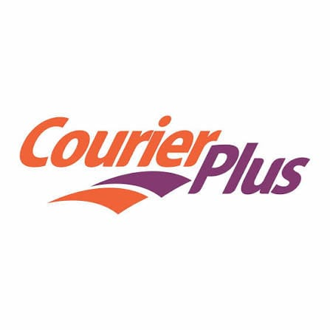 | CourierPlus  Unclaimed profile | Logistics | Nigeria

1993  Founded | 1  Leader profiled

Facts drawn from Brands.Ng records.

Key information
Industry | Logistics
Country | Nigeria
Founded | 1993
Head office | Lagos
Employees | 500+

About
CourierPlus is one of Nigeria’s established logistics and distribution companies, founded in 2009 and later acquired by Superflux Group in 2012. It began as a domestic express delivery business and has grown into a nationwide courier operator serving corporate clients across major Nigerian cities and states.
The company’s core business is the movement of documents, parcels, and cargo for organizations that need dependable delivery and reverse-logistics support. Its customer base includes banks, oil and gas companies, law firms, government agencies, telecom operators, and other institutions that rely on time-sensitive distribution. CourierPlus positions itself as an end-to-end logistics provider, meaning it does more than transport items; it supports the operational workflows that sit around delivery, tracking, and service coordination.
A major strength of CourierPlus is its geographic footprint. The company operates from more than 45 locations across Nigeria, including Lagos, Abuja, Port Harcourt, and other major commercial centres. That network gives it the reach needed to handle intercity and regional delivery at scale, which is especially important in a market where reliable logistics infrastructure can be uneven from state to state. Its branch system also helps it serve large institutions that need a single logistics partner with nationwide coverage.
CourierPlus has also adapted to the digital expectations of the modern logistics market. Like many long-standing operators, it has progressively digitised its booking and tracking processes in order to remain competitive with newer technology-led logistics firms. That shift matters because customers increasingly expect visibility, speed, and convenience in addition to physical delivery capability.
To be Nigeria's leading courier and logistics company by delivering excellence on every shipment. Mission statement

Trust and reputation measures
Trust Score  Not yet rated  Needs reviews and evidence | Profile Strength  42/100  Partially Complete | Evidence  No evidence recorded yet | Status  Unclaimed profile

Brands Trust Score A reputation measure built from approved reviews and evidence under a published methodology. It is not a measure of how complete a profile is, and payment never changes it.
Profile Strength How complete and well maintained the profile is. It does not change the Trust Score.
Evidence coverage How much of this profile is backed by recorded sources, and how independent they are.
Status No company representative has claimed this profile yet. It is compiled from public sources by Brands.Ng.

Brand identity
Primary logo

Leadership
Solomon Daramola | Managing Director and Chief Executive Officer

Media, contacts and social
Head office | Lagos

About this document
Generated on 23 October 2026 from the Brands.Ng Brand Passport.
It contains only published, sourced information and may have changed since. Check the linked sources before relying on a fact.
"Verified" means Brands.Ng has verified the company through its own review process. It is not a government certification and does not guarantee every statement.
Live profile: https://brands.ng/companies/courier-plus/
How to read the source labels
Company-confirmed | Supplied by an authorised company representative and approved by Brands.Ng.
Publicly documented | Backed by a regulator or other primary record.
Reported by independent source | Reported by a publication that is not the company.
Brands.Ng research | Compiled by Brands.Ng editors; never counted as independent corroboration.
Not publicly verified | No source yet. It is left blank rather than guessed.

