 | 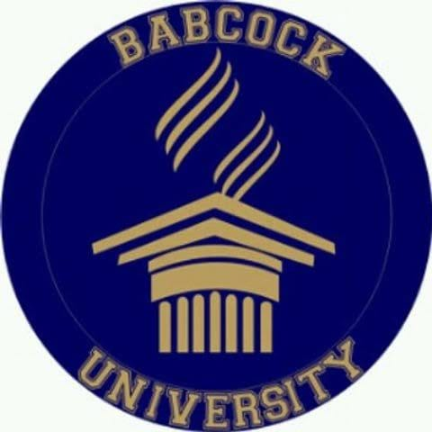 | Babcock University  Unclaimed profile | Education | Nigeria

Education  Industry | Nigeria  Country | Ilishan Remo Ogun State  Head office | 1999  Founded

Key information
Industry | Education
Country | Nigeria
Founded | 1999
Head office | Ilishan Remo Ogun State
Employees | 2000+

About
Babcock University is one of Nigeria’s most established private faith-based universities, founded in 1999 by the Seventh-day Adventist Church and located in Ilishan-Remo, Ogun State. It has built a strong reputation as a disciplined, values-driven institution that combines academic training with spiritual formation and personal development. Over the years, it has become a preferred choice for students and families seeking a private university environment with structure, consistency, and strong moral emphasis.
What makes Babcock stand out is its holistic model of education. The university’s founding philosophy goes beyond classroom learning to include spiritual, physical, and social development, creating an environment intended to shape the whole person. This approach is reflected in the campus culture, which is generally known for order, regulation, and a strong sense of community. For many students, that structure is part of the appeal, especially in a higher education landscape where stability and discipline are highly valued.
Babcock is also recognized for the breadth and credibility of its academic offerings. Its medical school is among the most visible parts of the institution, and programmes in nursing, pharmacy, computer science, and law attract students from across Nigeria. These disciplines have helped the university build a reputation for professional education with practical relevance. In particular, its health-related programmes have played a major role in shaping its public image as a serious academic institution rather than merely a faith-based college.
Another important part of Babcock’s growth has been its early investment in research capacity and institutional partnerships. As one of the earlier Nigerian private universities to build research infrastructure, it positioned itself to participate more actively in scholarly work and academic collaboration. Its international partnerships have also helped expose students and faculty to broader academic standards and global best practices, which adds to its appeal for students aiming for competitive professional careers.
To develop transformed and empowered lifelong learners for effective service to humanity. Mission statement

Trust and reputation measures
Trust Score  Not yet rated  Needs reviews and evidence | Profile Strength  38/100  Incomplete Profile | Evidence  No evidence recorded yet | Status  Unclaimed profile

Brands Trust Score A reputation measure built from approved reviews and evidence under a published methodology. It is not a measure of how complete a profile is, and payment never changes it.
Profile Strength How complete and well maintained the profile is. It does not change the Trust Score.
Evidence coverage How much of this profile is backed by recorded sources, and how independent they are.
Status No company representative has claimed this profile yet. It is compiled from public sources by Brands.Ng.

Brand identity
Primary logo

Latest news about Babcock University
30 May 2026 Covenant University Review 2026: Fees, Admission, Hostel & Student Life Explained
16 May 2026 Paystack Review 2026: Fees, Safety & Honest Verdict
Articles published on Brands.Ng that mention this company.

Media, contacts and social
Head office | Ilishan Remo Ogun State

About this document
Generated on 23 October 2026 from the Brands.Ng Brand Passport.
It contains only published, sourced information and may have changed since. Check the linked sources before relying on a fact.
"Verified" means Brands.Ng has verified the company through its own review process. It is not a government certification and does not guarantee every statement.
Live profile: https://brands.ng/companies/babcock-university/
How to read the source labels
Company-confirmed | Supplied by an authorised company representative and approved by Brands.Ng.
Publicly documented | Backed by a regulator or other primary record.
Reported by independent source | Reported by a publication that is not the company.
Brands.Ng research | Compiled by Brands.Ng editors; never counted as independent corroboration.
Not publicly verified | No source yet. It is left blank rather than guessed.

